**Assignment 11 – Visualization In D3**

**1.**

2.

3.

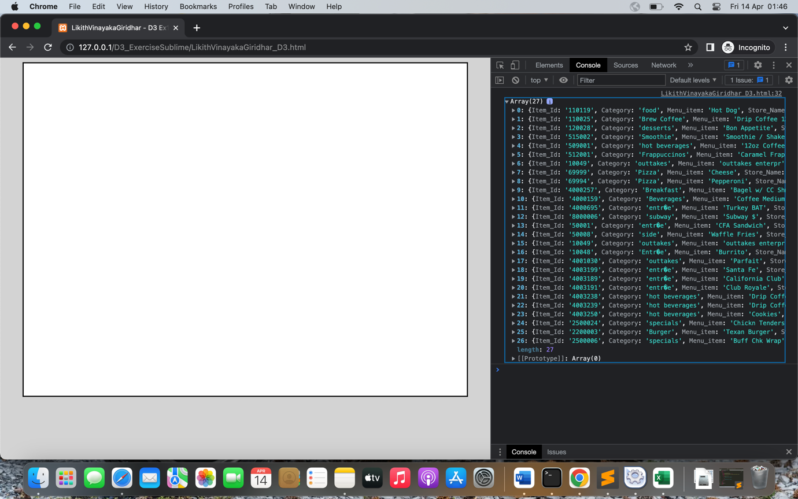

4.

5.

6.

7.

8.

9.

10.

11.

12.

13.

14.

